|  |
| --- |
| 4*yp games.inc* |
| Tower Defence |
| Web Game |
| Version v2.0  All work Copyright © 2015 by *YP Games*.  All rights reserved. |
| **Yun Kui Pan** |
|  |

****

|  |
| --- |
| Dec 18th 2015 |

Table of Contents

[I. Version History 3](#_Toc438230420)

[II. Game Overview 3](#_Toc438230421)

[III. Game Play Mechanics 3](#_Toc438230422)

[IV. Controls 3](#_Toc438230423)

[V. Detailed Game Description 3](#_Toc438230424)

[VI. Interface Sketch 3](#_Toc438230425)

[VII. Screen Descriptions 5](#_Toc438230426)

[VIII. Characters / Vehicles 6](#_Toc438230427)

[IX. Scoring 6](#_Toc438230428)

[X. Sound Index 6](#_Toc438230429)

[XI. Art / Multimedia Index 6](#_Toc438230430)

# Version History

Current Version: v2.0

Version Control is conducted by using github:

https://github.com/y-pan/TowerDefence

# Game Overview

This is a tower defence game. When Enemy gets to heart (the goal), player’s life would be decreased, and game is over when life is down to 0.

Drag and drop tower onto grass background to build tower, then update tower to increase the power.

Kill enemies before you lost your lives.

# Game Play Mechanics

Using mouse to drag, drop to update tower, and click to update tower level.

Tower will search enemy within its fire range, and keep shooting at it till it disappears.

# Controls

Mouse

# Detailed Game Description

Enemies will move along the stone tile path to the end/castle.

Player has to build tower to shoot enemies.

Building and updating tower all cost some money, while player can earn more money by killing enemies.

# Interface Sketch

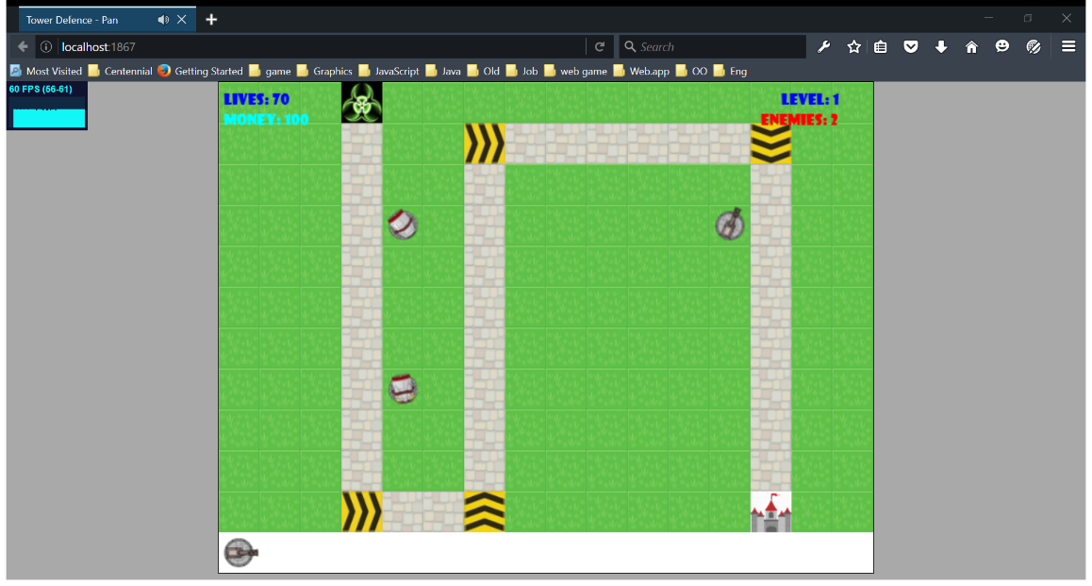

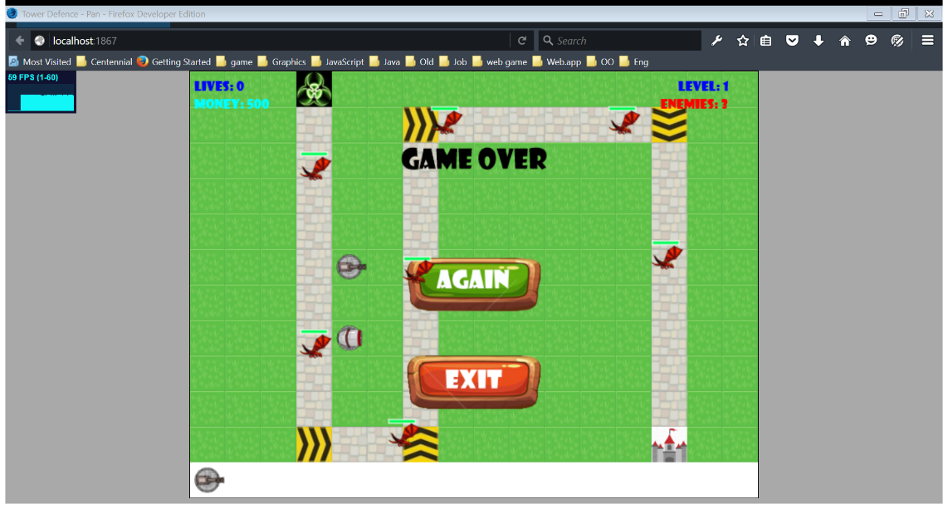

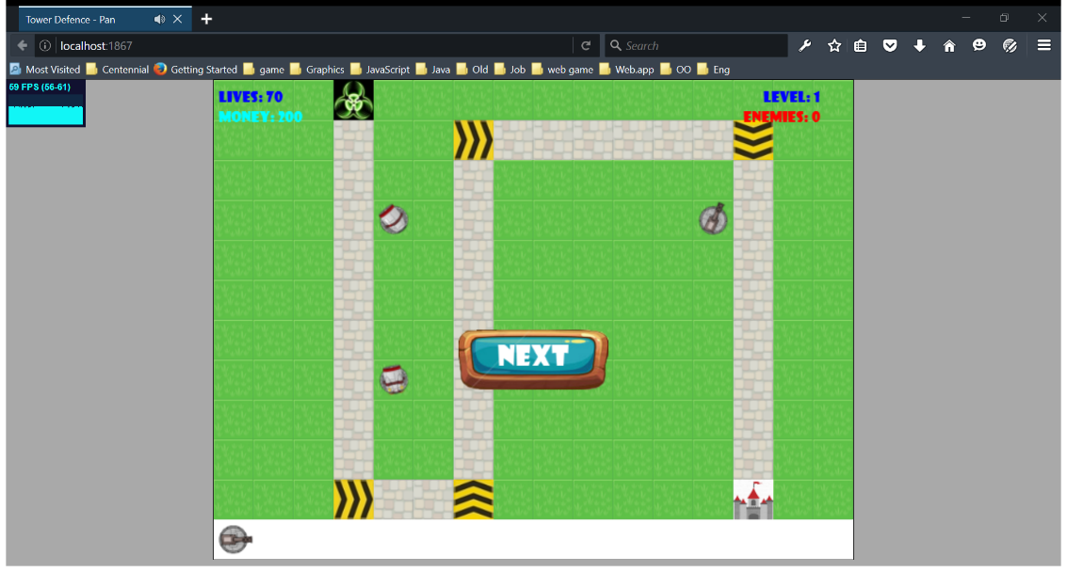

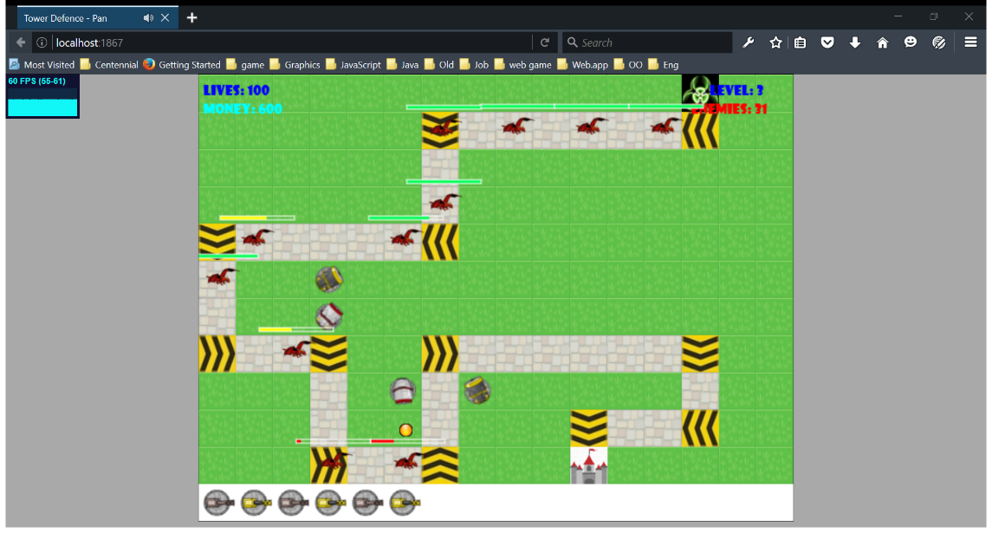

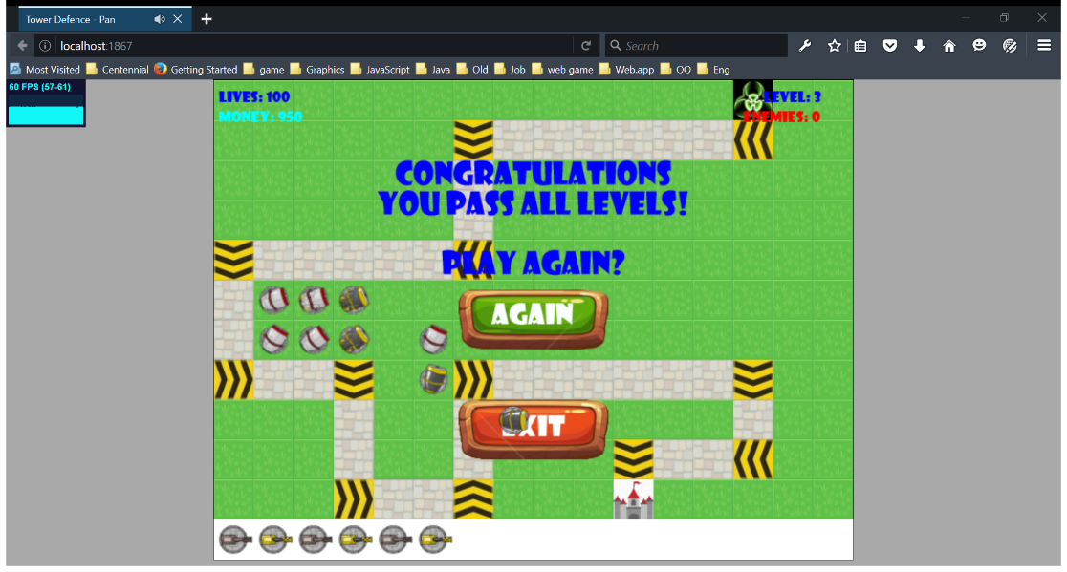

# Screen Descriptions

**Enemies’ life bar**

**Enemies’ start point**

**Lives**

**Blank Tile: place for tower to build on**



**Money**

**Direction Tile**

**Enemies’ moving path**

**Enemy**

**Tower**

**Castle (Home):**

**Enemies’ target**

**Tower Menu**

**Bullet**

# Characters / Vehicles

Enemies move along the rock tile path.

Towers are to be built on blank (grass) ground. They will search enemy within its range and fire at it, till it lost it, then search for the next target.

# Scoring

When player survive after all enemy waves, game will continue on next level.

# Sound Index

|  |  |
| --- | --- |
| **Sound clip** | **Usage** |
| 1. horn.mp3 | for game beginning |
| 2. ta\_buttonPress.mp3 | for pressing button |
| 3. Forest-Chase.mp3 | game background music |
| 4. powerUp.mp3 | when tower is built or updated |
| 5. blop.mp3 | sound for tower shooting |
| 6. dingdong.mp3 | sound when enemy touch castle (home) |

# Art / Multimedia Index

|  |  |
| --- | --- |
| **Item Name** | **Image** |
| 1. Button | **s:\Documents\My Web Sites\TowerDefence\TowerDefence\Assets\images\next_button.png**  **s:\Documents\My Web Sites\TowerDefence\TowerDefence\Assets\images\start_button.png**  **s:\Documents\My Web Sites\TowerDefence\TowerDefence\Assets\images\again_button.pngs:\Documents\My Web Sites\TowerDefence\TowerDefence\Assets\images\menu_button.png**  **s:\Documents\My Web Sites\TowerDefence\TowerDefence\Assets\images\exit_button.png** |
| 2. tower | **s:\Documents\My Web Sites\TowerDefence\TowerDefence\Assets\images\tb3.pngs:\Documents\My Web Sites\TowerDefence\TowerDefence\Assets\images\tb2.pngs:\Documents\My Web Sites\TowerDefence\TowerDefence\Assets\images\tb1.png**  **s:\Documents\My Web Sites\TowerDefence\TowerDefence\Assets\images\ta1.pngs:\Documents\My Web Sites\TowerDefence\TowerDefence\Assets\images\ta3.pngs:\Documents\My Web Sites\TowerDefence\TowerDefence\Assets\images\ta2.png** |
| 3. bullet | **s:\Documents\My Web Sites\TowerDefence\TowerDefence\Assets\images\bullet1.pngs:\Documents\My Web Sites\TowerDefence\TowerDefence\Assets\images\bullet3.pngs:\Documents\My Web Sites\TowerDefence\TowerDefence\Assets\images\bullet2.png** |
| 4. enemy | **s:\Documents\My Web Sites\TowerDefence\TowerDefence\Assets\images\redDragon.png** |
| 5. tile |  |